**Software Design Document**

**<Travia>**

Version 1.0



**Submitted by**

Muhammad Husnain Arshad (F24BINFT7M04027)

Muhammad Danish Sattar (F24BINFT7M04008)

**Submitted to**

***Dr. Muhmmad Asad Ullah***

**Department of Information Technology**

**Faculty of Computing**

**The Islamia University of Bahawalpur**

**Summery**

This Software Design Document (SDD) aims at outlining the detailed design of the TRAVIA TRAVEL MANAGEMENT APPLICATION, which has been developed using the Flutter framework for the front end as well as the Firebase backend platform. The main objective of the Software Design Document is to explain the elaborated requirements developed in the Software Requirements Specification (SRS) document for the implementation of the system design. The Software Design Document acts as the technical blueprint that assists developers in interpreting the internal workings of the developed software.

The TRAVIA system is intended to serve as a one-stop travel manager service for users in Pakistan. The system brings together a range of travel services in a platform such as travel package viewing and booking, map services for route navigation, expense management during travel, reviews, and administrative tasks. Unlike other systems which are designed to handle only a particular aspect of traveling, TRAVIA takes a one-stop approach to manage all stages of a trip journey – planning to final trip reviews.

In the document, the application architecture and flow, important components of the application, and inter-component interaction between various software modules including user authentication, package and user management, booking functionality, navigation functionality, expense tracking functionality, and admin monitoring functionality will also be discussed. Additionally, it will provide a data schema that displays important entities and their relationship to travel packages, books, and expenses. Finally, the application interface design principles to ensure usability and accessibility to all users will also be covered in the document.

**Table of Content**

**1. Introduction…………………………………………………………………………………………………………………………………..4**

**1.1. Scope ……………………………………………………………………………………………………………………………………...4**

**1.2. Purpose……………………………………………………………………………………………………………………………………4**

**2. Application Architecture...................................................................................................................5**

**2.1. Architectural Design………………………………………………………………………………………………………………….5**

**2.2. Presentation Layer…………………………………………………………………………………………………………………….6**

**2.3. Business Logic Layer (Controllers)……………………………………………………………………………………………..7**

**2.4. Data Layer…………………………………………………………………………………………………………………………………8**

**2.5. External APIs and Services…………………………………………………………………………………………………………8**

**2.6. Architectural Diagram……………………………………………………………………………………………………………….9**

**3. Data Model Schema………………………………………………………………………………………………………………………10**

**3.1. Data Flow Diagram…………………………………………………………………………………………………………………10**

**3.2. Data Design…………………………………………………………………………………………………………………………….11**

**4. User Interface……………………………………………………………………………………………………………………………….15**

**4.1. Design Principles…………………………………………………………………………………………………………………….15**

**4.2. Screen Descriptions…………………………………………………………………………………………………………………15**

**4.3. User Interface Diagrams………………………………………………………………………………………………………….19**

**1. Introduction**

This Software Design Document (SDD) provides a comprehensive description of the design of TRAVIA Travel Management Application. The primary objective of this document is to translate the functional and non-functional requirements defined in the Software Requirements Specification (SRS) into a well-structured technical design that supports systematic system development and implementation. TRAVIA is developed as an integrated mobile application that facilitates travel planning, package browsing and booking, navigation support, expense tracking, and post-travel reviews through a unified platform. This document outlines the system architecture, module organization, data model, and user interface design of the application.

**1.1. Scope**

The scope of the TRAVIA system encompasses user registration and authentication, travel package management, booking processing, map-based navigation, expense monitoring, and review and rating functionalities. The system supports two primary user roles: travelers and administrators. Travelers are able to browse available travel packages, make bookings, utilize navigation services, track travel-related expenses, and submit reviews, while administrators are responsible for managing travel packages, monitoring system usage, and maintaining application data. TRAVIA is implemented as a mobile application using Flutter for the presentation layer and Firebase for backend services, with integration of external services such as Google Maps, Google Places, and Google Distance Matrix APIs. Certain advanced features, including online payment processing and real-time communication, are intentionally excluded from the current version to maintain feasibility within academic project constraints and are considered for future enhancement.

**1.2. Purpose**

The purpose of this Software Design Document (SDD) is to provide a detailed and structured description of the design and architecture of TRAVIA Travel Management Application. This document serves as a technical reference that translates the requirements defined in the Software Requirements Specification (SRS) into an implementable design framework by describing the organization and interaction of system components, modules, data structures, and user interfaces. It is intended to guide developers during system implementation by outlining key architectural decisions, module responsibilities, data organization, and interface behavior, while also assisting project supervisors, evaluators, and stakeholders in understanding the internal system design and verifying that the proposed solution fulfills the specified requirements. Furthermore, this document provides a foundation for future system maintenance, enhancement, and scalability by documenting design decisions in a clear and consistent manner.

**2. Application Architecture**

The TRAVIA application will have a modular, layered design. This will make the app scalable, easily maintainable, and easily upgradeable in the future. The architecture clearly separates tasks, following MVVM ideas, so that the user interface, business logic, and data management are kept separate and treated independently.

**2.1. Architectural Design**

TRAVIA is a client-server mobile application that uses Firebase for backend services and Flutter for client-side development. In order to facilitate navigation and location-based services, the application interacts with external third-party APIs. Realtime data synchronization, safe authentication, and effective management of travel-related data are all made possible by this architectural strategy.

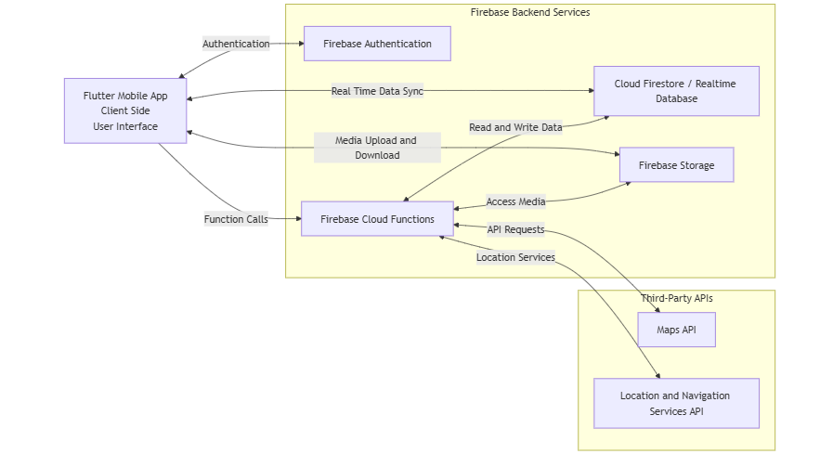

**Figure 1:** Architectural design Diagram

**2.2. Presentation Layer**

The presentation layer is responsible for handling all user interactions and presenting information to the users. It will be developed on Flutter and contains several screens like login, registration, home dashboard, browsing of packages, package details, booking interface, map for navigation, expense tracking, and admin dashboard screens. The UI layer will not include business logic; instead, it routes the user actions to the respective controllers and displays the received data in a user-friendly manner.

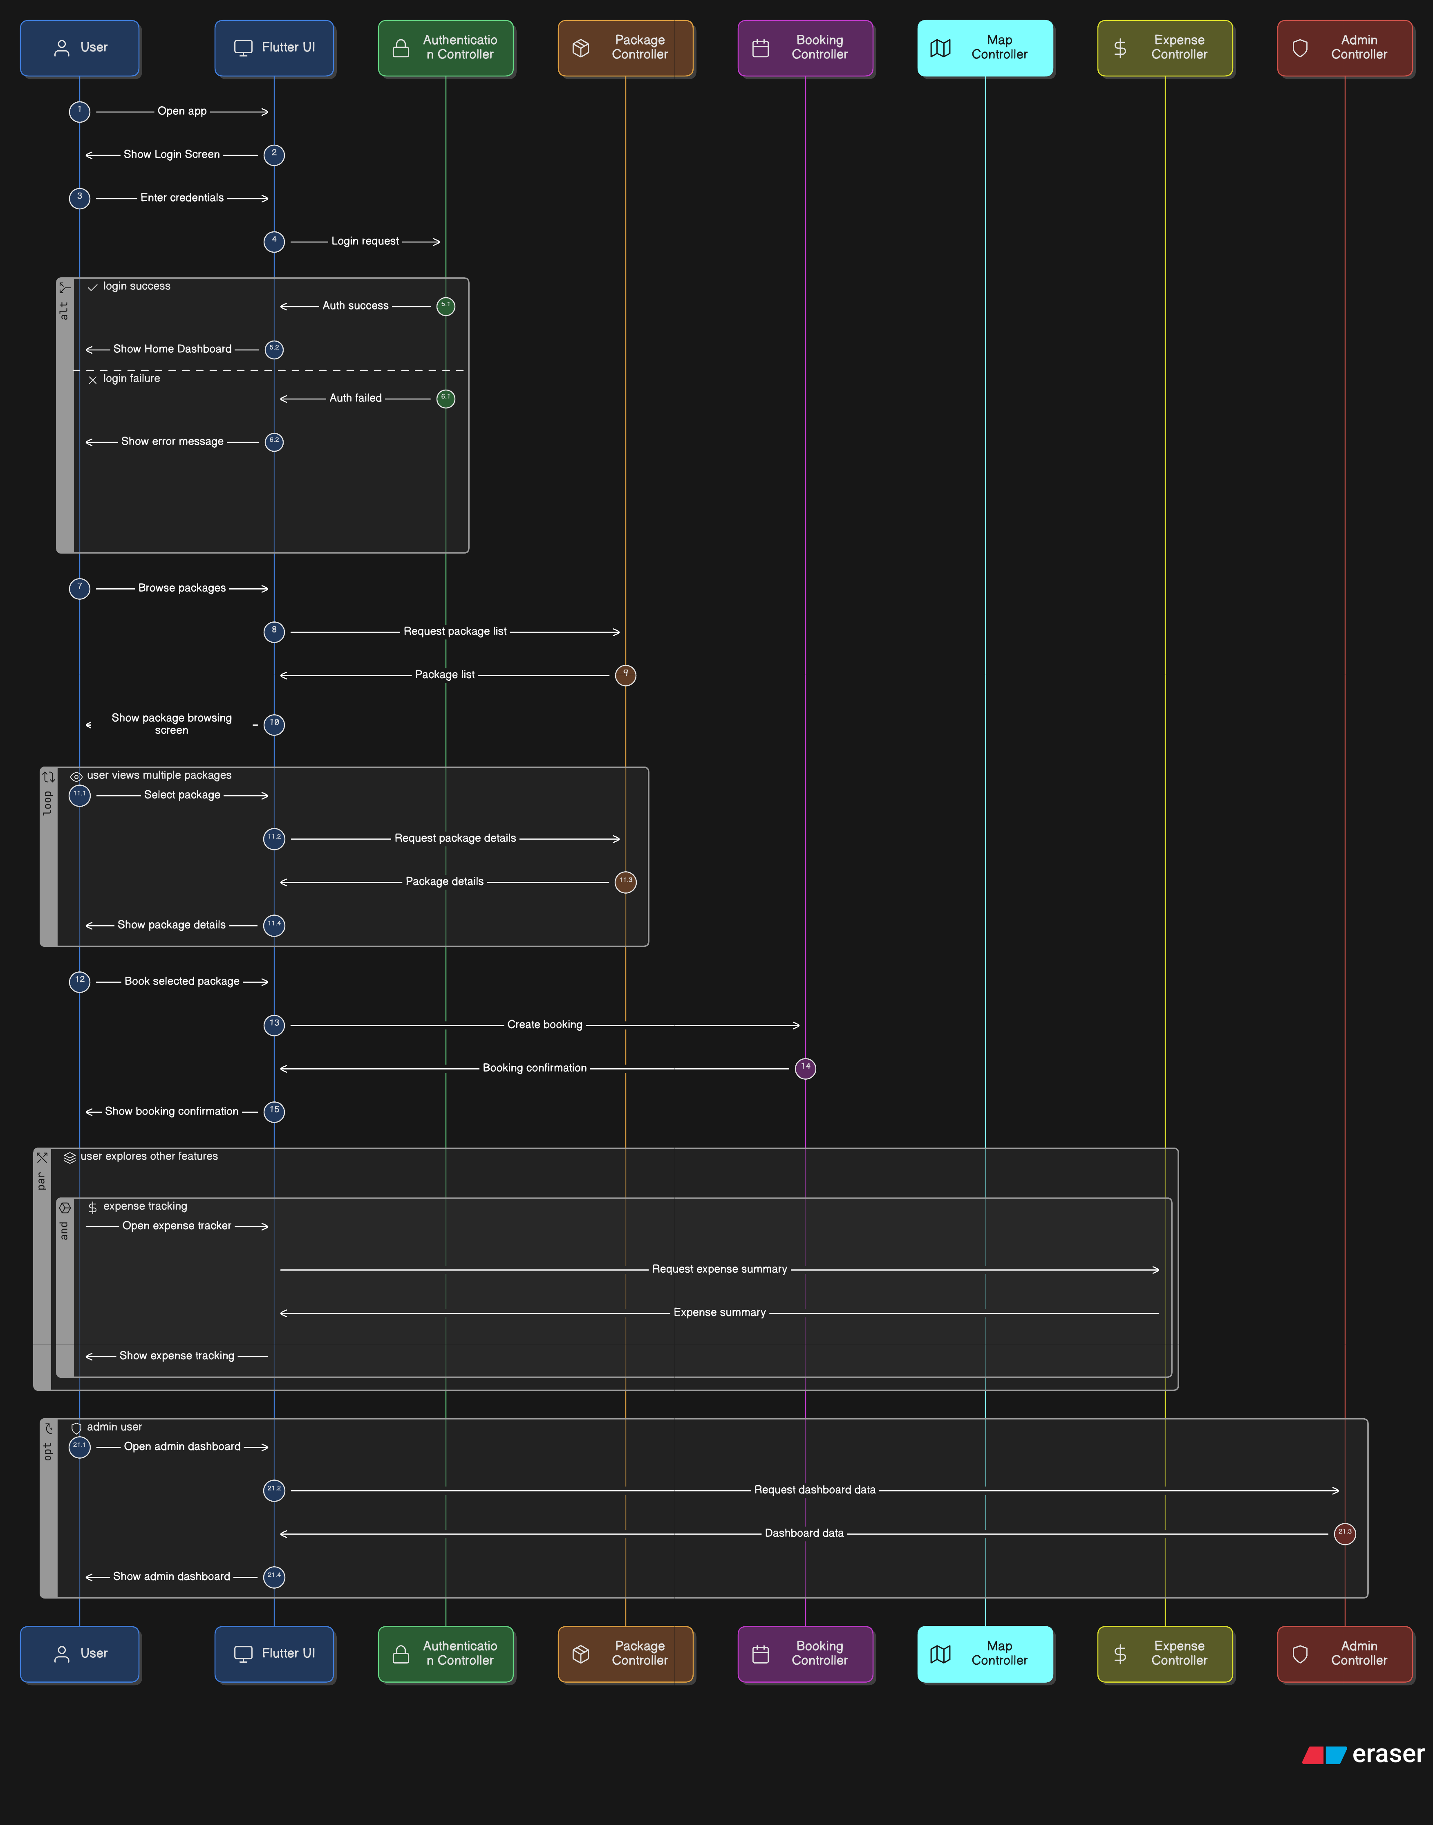

**Figure 2:** User Interference Diagram

**2.3. Business Logic Layer (Controllers)**

The Business Logic Layer acts as an intermediary between the User Interface and the Data Layer, comprising controllers that process user requests, enforce validation rules, and manage data flow between UI and back-end services.

The main controllers utilized in the TRAVIA are:

* **Authentication:** This controller handles user sign-up, login, logout, and sessions through Firebase Authentication.
* **Package Controller:** This handles package retrieval, searching, filtering, and display.
* **Booking Controller:** Handles creating bookings, confirming them, canceling, and showing history.
* **Map Controller:** This module integrates services provided by Google Maps to show routes, calculate distances, and provide navigation.
* **Expense Controller:** records, updates, and retrieves the travel-related expenses of the users.
* **Admin Controller:** Handles all administrative tasks, such as package approval, user management, and system monitoring.

Each controller is responsible for specific tasks of its domain; this ensures modularity and ease of maintenance.

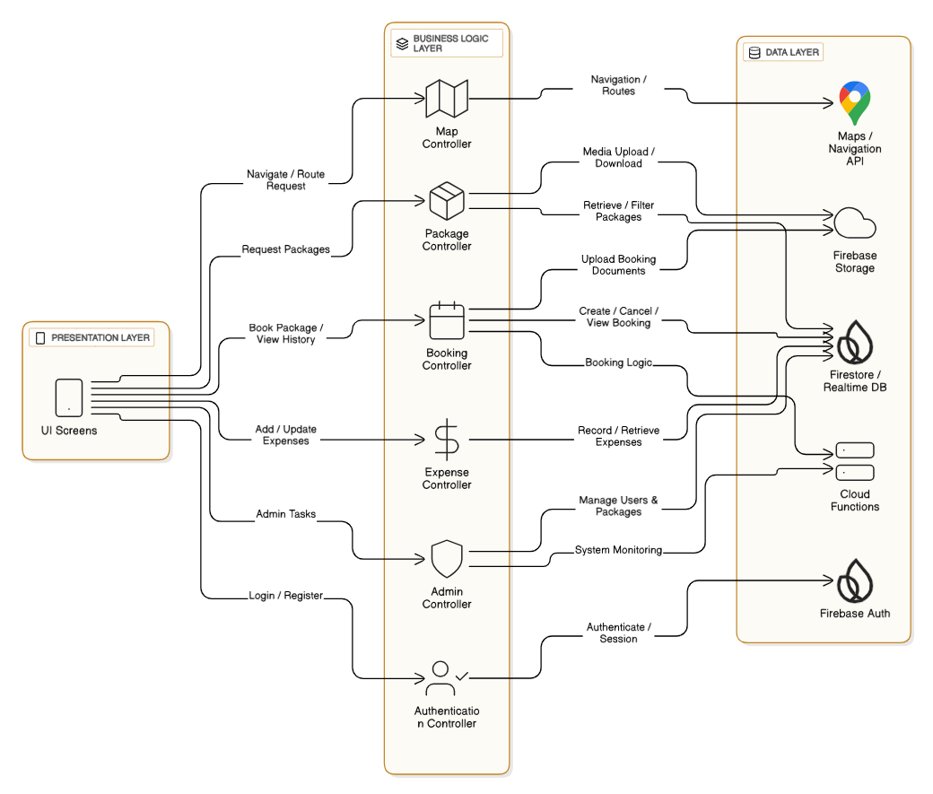

**Figure 3:** Logic LayerDiagram

**2.4. Data Layer**

The data layer is responsible for storing, retrieving, and managing application data. Firebase Firestore is used as the main database for the storage of user profiles, travel packages, bookings, reviews, and expense records. Firebase Authentication implements secure access control, while Firebase Cloud Storage can be utilized to store images and documents related to the travel packages. The data layer provides real-time updates and synchronization between the client application and the backend.

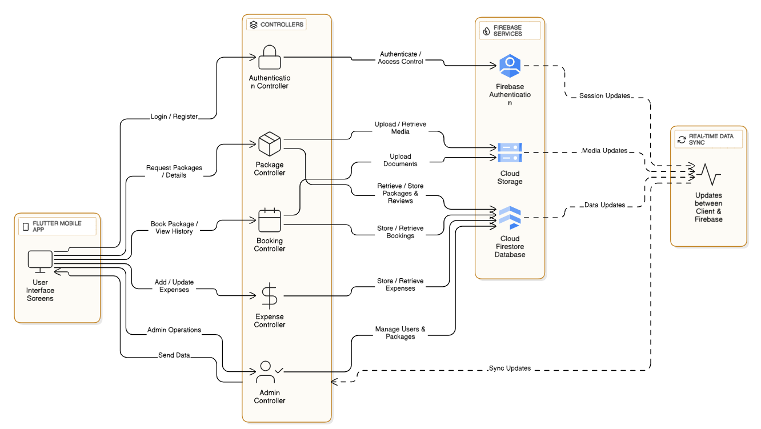

**Figure 4:** Data LayerDiagram

**2.5. External APIs and Services**

TRAVIA combines numerous external APIs that enhance its functionality in relation to travel. It makes use of the Google Maps API for map and route displays, the Google Places API to fetch nearby hotels, restaurants, and ATMs, and the Google Distance Matrix API to calculate the approximate travel distance and time. These APIs allow for the correct navigation and location-based decision-making by the user during his or her travel.

**2.6. Architectural Diagram**

This section depicts the overall architecture of TRAVIA using an application architecture diagram, which shows the interaction of the Flutter-based mobile application with business logic controllers, Firebase backend services, and external map-related APIs. This diagram presents a clear visual understanding of how data flows across different system components.

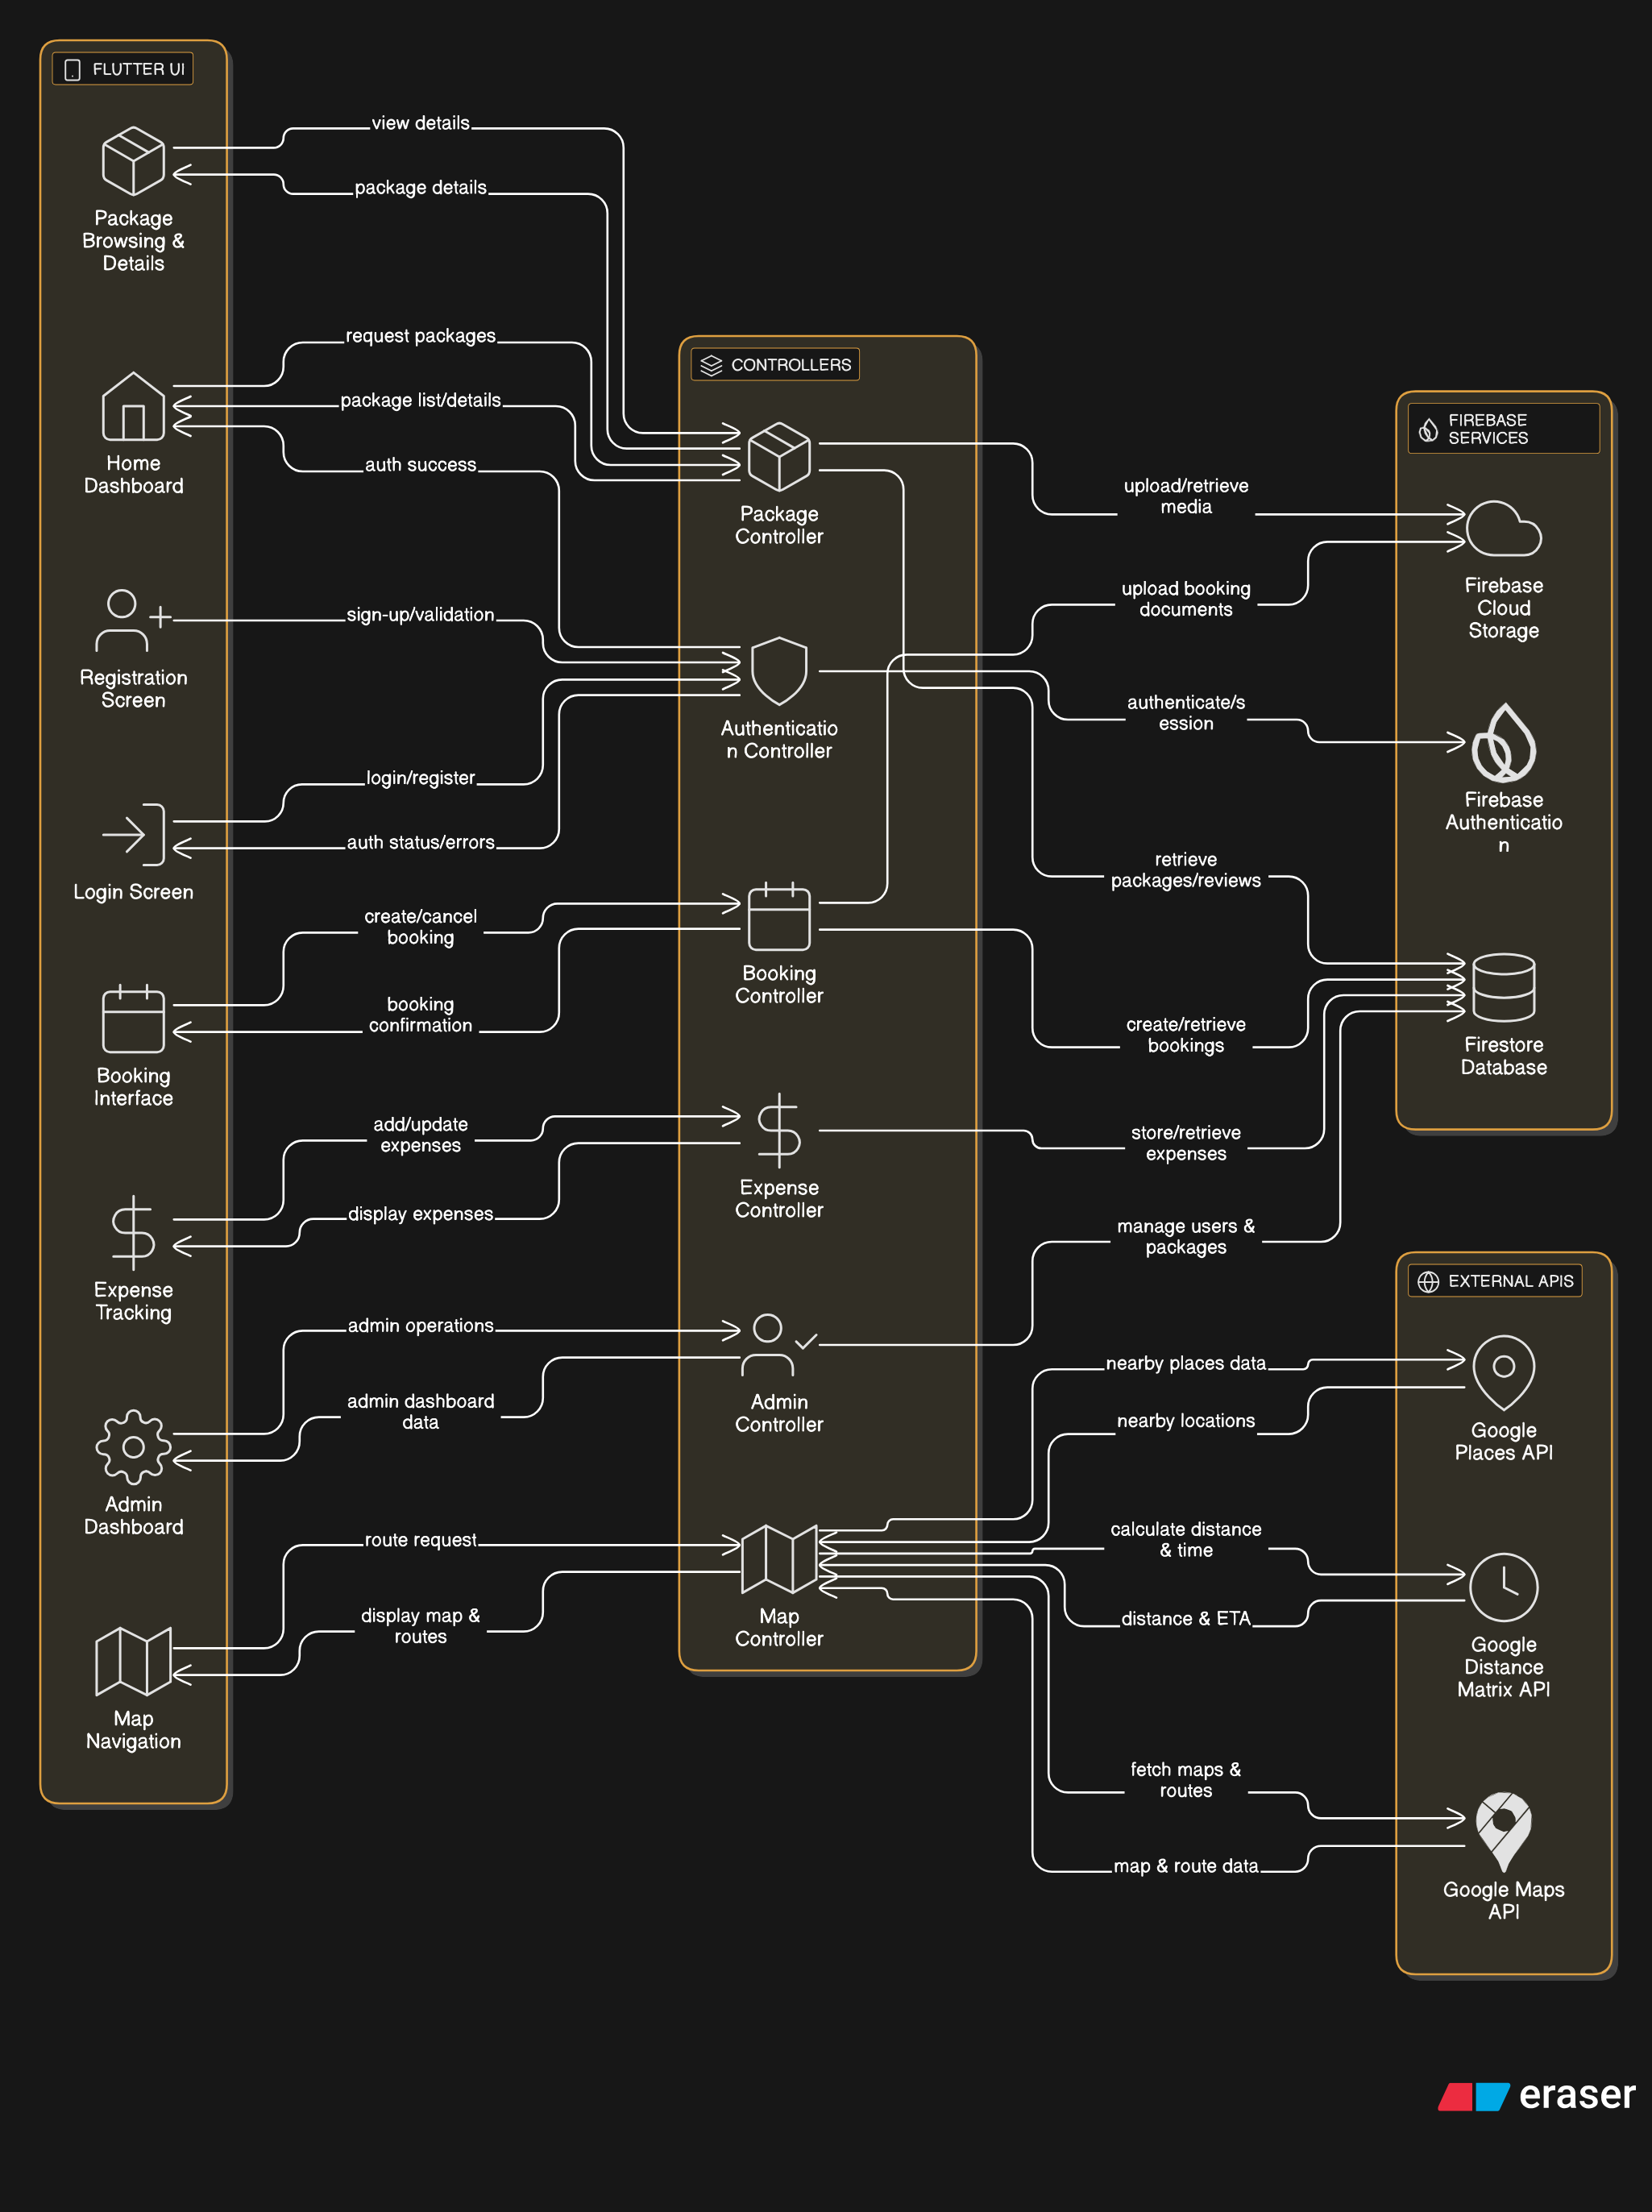

**Figure 5:** Architectural Diagram

**3. Data Model Schema**

The TRAVIA data model schema defines the conceptual structure of data that would be required to support functionality related to travel planning, booking, navigation, and expense tracking. The system uses Firebase Firestore, a NoSQL document-based database that will store and manage the application data. The data model is designed with the intent of efficiently scaling storage, allowing for ease in retrieving user and travel-related information.

**3.1. Data Flow Diagram**

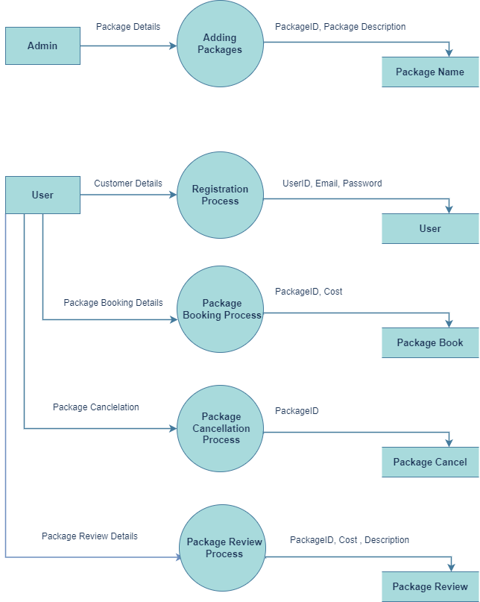

**Figure 6:** Data Flow Diagram

**Detailed Data Flow Diagram:**

1. **Adding Packages:**

•**Entity:** Admin

• **Process:** The admin adds travel packages by entering package-related details such as Package-ID and package description.

• **Output:** The package information, including the package name, is stored in the system.

1. **Registration Process:**  
   • **Entity:** User  
   • **Process:** Users register in the system by providing personal details such as UserID, email address, and password.  
   • **Output:** The registered user information is saved in the system.
2. **Package Booking Process:**  
   • **Entity:** User  
   • **Process:** Users book a travel package by selecting package details such as PackageID and cost.  
   • **Output:** The booking information is recorded in the system.
3. **Package Review Process:**  
   • **Entity:** User  
   • **Process:** Users submit feedback for booked packages by providing details such as PackageID, cost, and description.  
   • **Output:** The review details are stored in the system.
4. **Package Cancellation Process:**  
   • **Entity:** User  
   • **Input:** Booking ID and cancellation request.  
   • **Output:** A cancellation confirmation or refund initiation is generated by the system

**3.2. Data Design**

The data design for **TRAVIA - Travel Management Application** focuses on transforming user interactions and system processes into well-structured data stored in **Firebase Firestore**, a NoSQL cloud-based database. The data design ensures efficient storage, retrieval, and management of travel-related information while supporting scalability and real-time updates.

Firestore organizes data into collections and documents, allowing TRAVIA to store structured yet flexible data for users, travel packages, bookings, reviews, and expenses. This approach supports dynamic application features such as real-time booking updates, expense tracking, and user reviews.

**Transformation of Information into Data Structures**

**1. User Data**

* **Purpose:** To store user-related information including authentication details, profile data, and user roles. This data supports login, authorization, and personalized application features.
* **Data Structure:** Stored in a Firestore collection named **Users**.
* **Fields include:**
* **UserID:** Unique identifier for each user
* **Name:** Full name of the user
* **Email:** Email address used for authentication
* **PhoneNumber:** Contact number of the user
* **Role:** Defines user type (Traveler or Admin)
* **CreatedAt:** Account creation timestamp

**2. Package Data**

* **Purpose:** To store and manage travel package information offered through the application. This data enables users to browse, compare, and select travel packages.
* **Data Structure:** Stored in a Firestore collection named **Packages**.
* **Fields include:**
* **PackageID:** Unique identifier for each travel package
* **Title:** Name of the travel package
* **Destination:** Travel location
* **Description:** Detailed package information
* **Duration:** Length of the trip
* **Price:** Cost of the package
* **Availability:** Availability status of the package
* **AverageRating:** Average rating given by users

**3. Booking Data**

* **Purpose:** To track and manage bookings made by users. This data connects users with selected travel packages and maintains booking history.
* **Data Structure:** Stored in a Firestore collection named **Bookings**.
* **Fields include:**
  + - **BookingID:** Unique identifier for each booking
    - **UserID:** Reference to the user who made the booking
    - **PackageID:** Reference to the booked travel package
    - **TravelDate:** Selected travel date
    - **NumberOfPersons:** Total travelers
    - **TotalCost:** Calculated booking cost
    - **Status:** Booking state (Pending, Confirmed, Cancelled)
    - **CreatedAt:** Booking creation timestamp

**4. Review Data**

* **Purpose:** To store user feedback and ratings after completing a trip. Reviews help improve service quality and assist future users in decision-making.
* **Data Structure:** Stored in a Firestore collection named **Reviews**.
* **Fields include:**
  + - **ReviewID:** Unique identifier for each review
    - **UserID:** Reference to the reviewing user
    - **PackageID:** Reference to the reviewed package
    - **Rating:** Numeric rating (1–5)
    - **ReviewText:** Written feedback
    - **ReviewDate:** Date of review submission

**5. Expense Data**

* **Purpose:** To track travel-related expenses incurred by users during their trips. This data supports budget management and expense analysis.
* **Data Structure:** Stored in a Firestore collection named **Expenses**.
* **Fields include:**
  + - **ExpenseID:** Unique identifier for each expense record
    - **UserID:** Reference to the user
    - **BookingID:** Reference to the related booking
    - **ExpenseType:** Category of expense (Transport, Food, Hotel, Fuel, Other)
    - **Amount:** Expense cost
    - **ExpenseDate:** Date of expense
    - **Notes:** Additional details (optional)

**Data Relationships**

* A User can make multiple Bookings
* A Package can have multiple Bookings and Reviews
* A Booking can include multiple Expenses
* 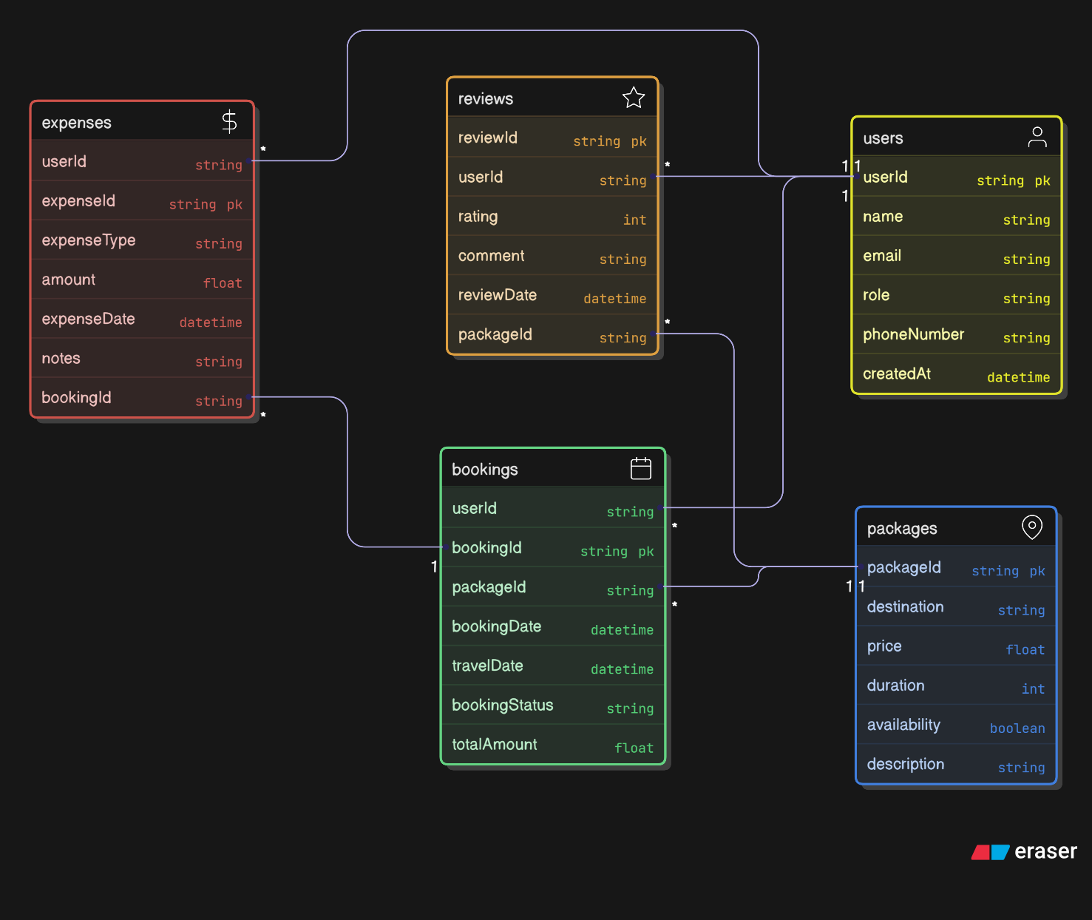A User can submit multiple Reviews and record multiple Expenses

**Figure 7:** ClassDiagram

**4. User Interface**

For travelers and administrators, the user interface of TRAVIA was designed to be simple, intuitive, and user-friendly. Focus has been put on usability, consistency, and accessibility so that users can work their way around the application easily and execute tasks with the least effort. Flutter is used to implement responsive interfaces across a variety of screen sizes and device types.

**4.1. Design Principles**

Accordingly, the design of this interface follows key usability principles: simplicity, consistency, clear navigation, and minimal user input. The reuse of common UI components and layout on multiple screens contributes to visual consistency, making it easy for new users to learn the application.

**4.2. Screen Descriptions**

* **Authentication Screens**

Login and registration screens will allow the user to access the application securely. Simple input fields, validation messages, and clear action buttons are provided to ensure smooth authentication.

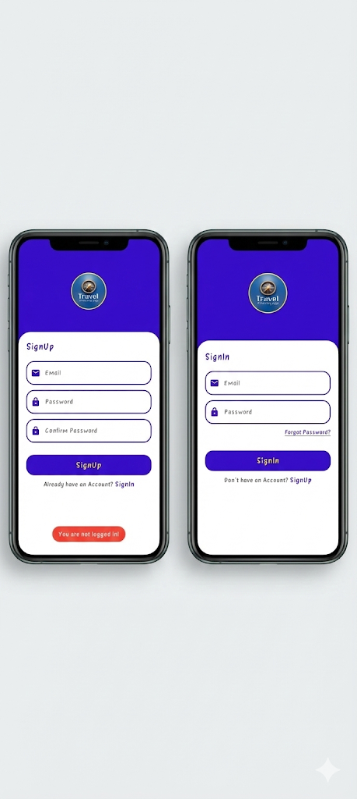

**Figure 8:** Login & Sign-up Screen

* **Home Dashboard:**

The home screen will provide the main navigation hub of the application, where featured packages, search functionality, and category filters allow the user to quickly explore options available.

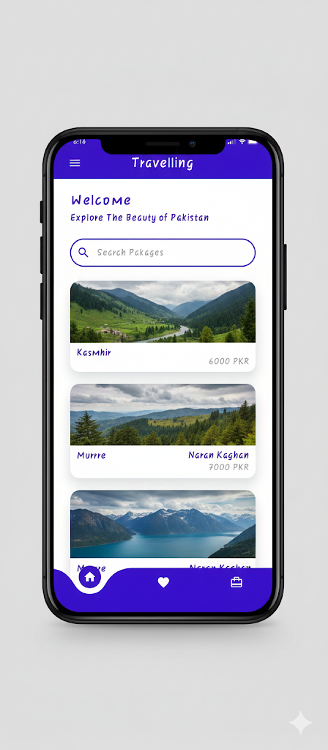

**Figure 9:** Home Dashboard Screen

* **Package Listing & Details Screens:**

The listing screen of the packages displays the travel packages in a card-based layout along with key information such as price, destination, and ratings. The details screen of the package provides all information, including an itinerary, reviews, map preview, and booking options.

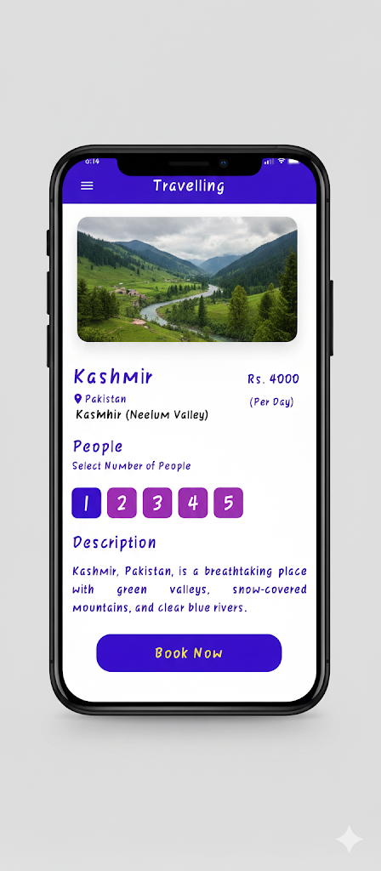

**Figure 10:** Package Listing & Details Screens

* **Booking Screen:**

With the booking interface, one can select the dates of travel, the number of travelers, and then confirm the bookings. The design uses a step-by-step layout to minimize errors by improving clarity.

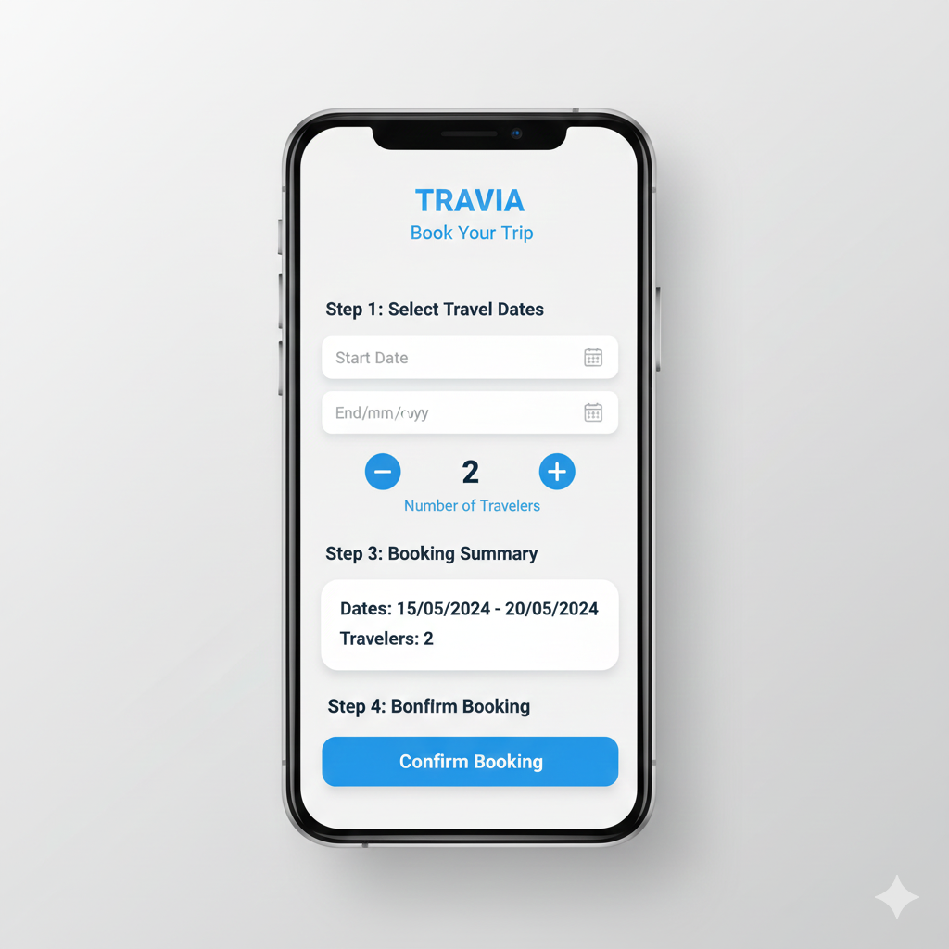

**Figure 11:** Booking Screens

* **Map and Navigation Screen:**

This screen integrates Google Maps services to display routes, travel distance, estimated time, and nearby locations. It supports real-time navigation to enhance the travel experience.

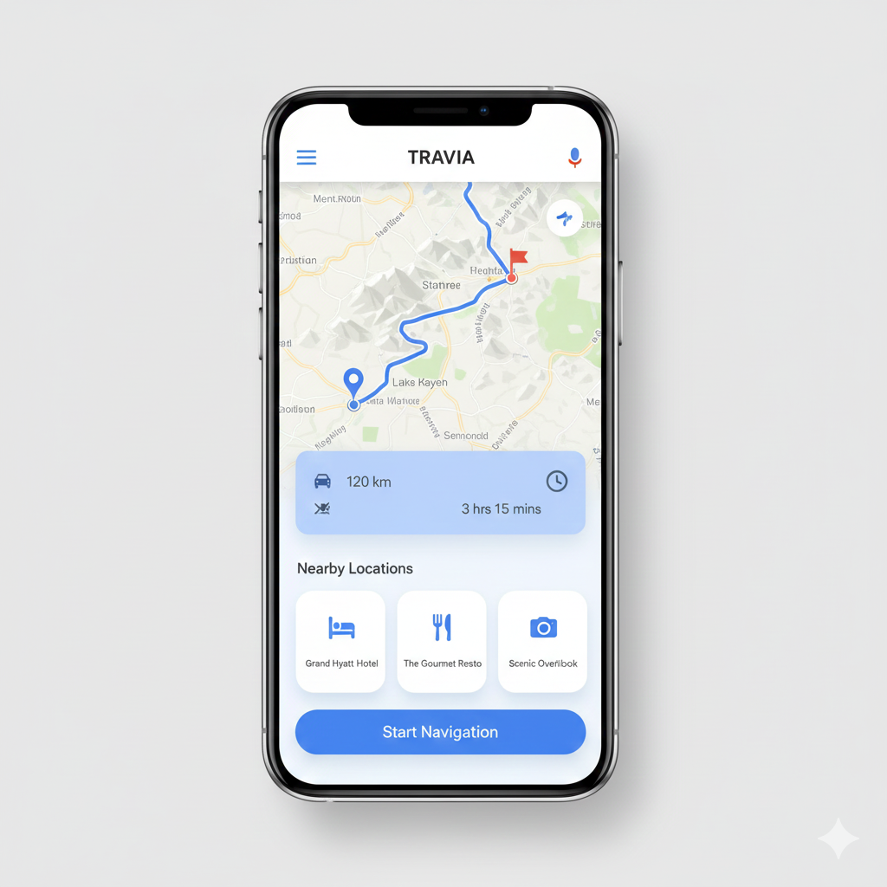

**Figure 12:** Map Screen

* **Expense Tracking Screen:**

The expense tracking interface enables users to record and manage travel expenses. Users can add expenses, view categorized lists, and monitor total spending during their trips.

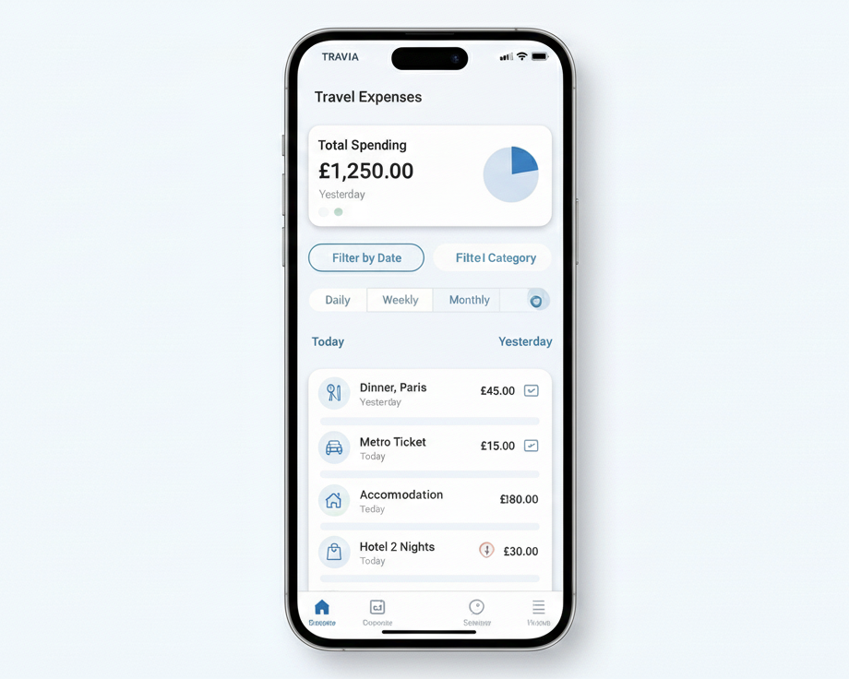

**Figure 13:** Expenses Screens

* **Admin Dashboard:**

The admin interface provides tools for managing travel packages, monitoring user activity, and maintaining system data. The dashboard is designed to support efficient administrative operations.

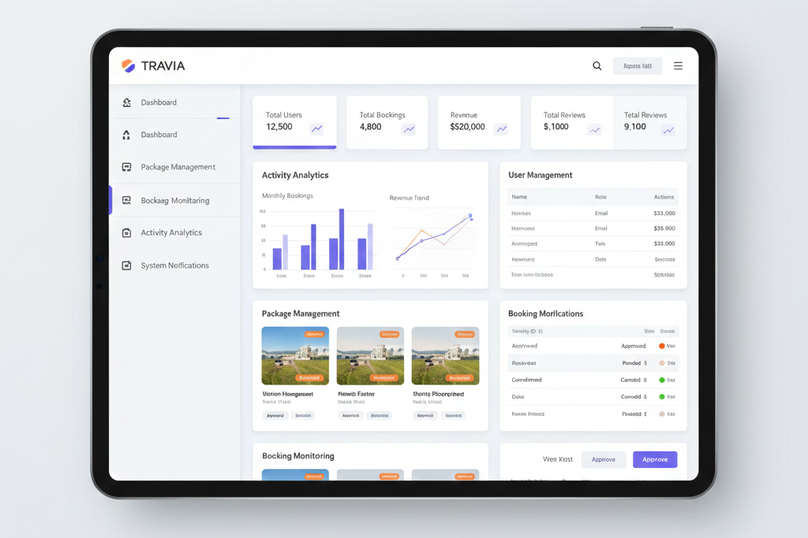

**Figure 14:** Admin Dashboard Screens

**4.3. User Interface Diagrams**

Wireframes and screen mockups are used to visually represent the layout and navigation flow of the TRAVIA application. These diagrams help in understanding screen structure and user interaction patterns.

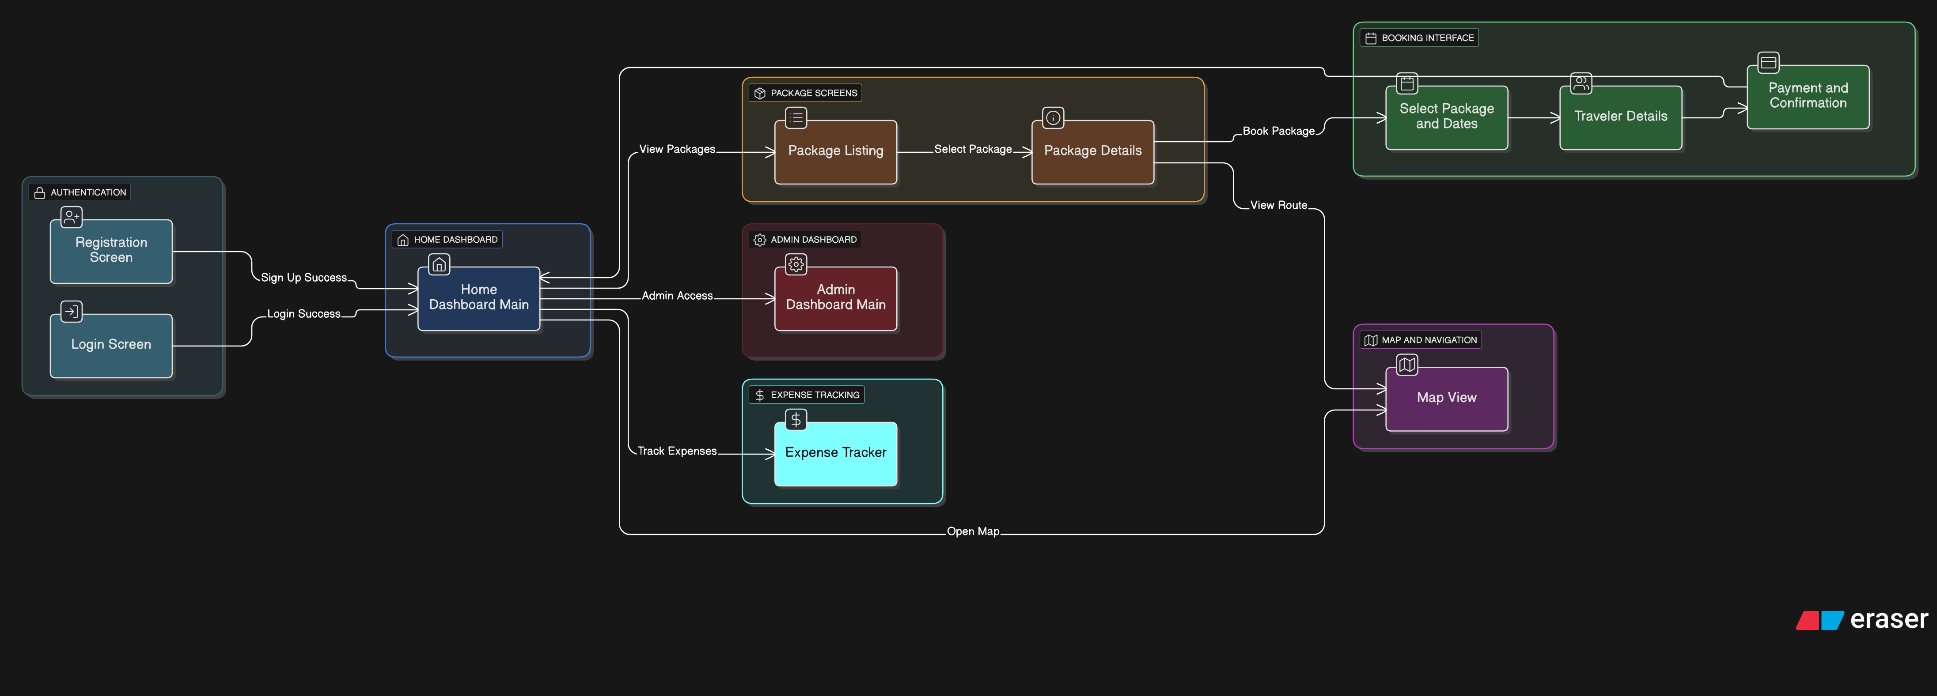

**Figure 15:** User Interference Diagram